BUOYANCY

What you will need:

1. One medium sized plastic milk bottle in a shape of a boat
2. A pair of scissors
3. Extra pieces of plastic for support if needed (extra plastic milk bottle and/or plastic juice bottle
4. Heavy objects that are quite small such as rocks
5. Large objects that are incredibly light
6. A large bucket filled 3/8 of the way
7. Glue (glue from a hot glue gun is preferred)

Instructions

Aim:
The aim of this experiment is to see the amount of weight my boat can hold in the water. We are testing buoyancy-the weight of an object against the up thrust of the water.
Hypothesis:
I predict that my sturdy boat will be able to hold at least 20 pebbles and/or 30 light things that are quite large. Furthermore, the objects and the weight will have to be spread out to prevent the boat from sinking on one side.
Method:
Firstly, gather all of your equipment and
fill the bucket with the water 2/8 of the way.
Next, take the pair of scissors and the medium sized plastic milk bottle and cut only one part out of the milk bottle. Specifically, cut the part beneath the handle.
Place the prepared boat in the water in the bucket.
Test the boat by placing heavy objects and light objects in the boat. To make this a fair test, always keep the same amount of water and boat and only change the objects in the boat.
If the boat cannot hold anything, add extra light support.
Cut the flat side of the extra milk bottle out and glue it to the base of your boat.
Use the remains from the plastic milk bottle to create sides for the open area. Once done, take the two pieces of plastics and glue them to the sides of the open area on your boat.
Take the juice bottle and cut the exact same length of your top of the open area on the boat out of the juice bottle. Glue this piece of plastic to the top of the open area of the boat.
Retest your boat in the water with the objects you have chosen.
Record your results and take pictures to see the outcome of the experiment.
Finally, decorate your boat if you want and have fun!

The boat holds ten rocks and it is afloat.

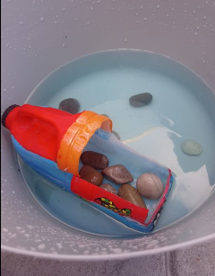

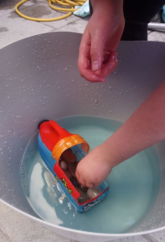
I am attempting to place 20 rocks into my boat.

Results

My results were very interesting and were very close to my hypothesis. Firstly, there was not a lot of water which went little up thrust but if I added more water everything will float and it wouldn’t be an affective test. Furthermore, the objects had to be evenly based in the boat.
The first test:
I placed 10 small rocks into the boat and see if that would float. That test went successful- the boat was able to hold ten rocks for all of time.
The second test:
For this test, I placed 20 small rocks in the boat- this test was unsuccessful and the boat wasn’t able to stay afloat. Subsequently, I took two rocks which brought the rocks to a total of 18 and this was able to hold for all of time.
The third test:
For this test, I placed large objects that are light in the boat. I placed 6 small, solid toys (no air), one flat lollipop stick; one plastic air filled baking roller and three long rubber tubes with air holes in. These objects made the boat sink.
Test 4:
I took objects out from the previous test and I was left with the objects: 2 solid, small toys, 1 flat lollipop stick, three rubber tubes with air holes and one plastic air filled roller. This is the maximum my boat can hold.
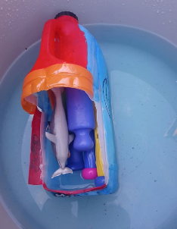
This is the large but light objects in the boat without sinking.

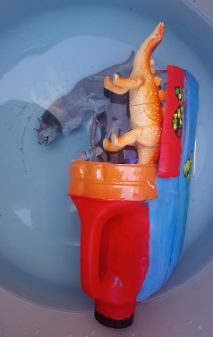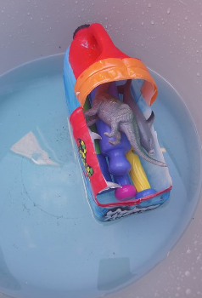
This is another image when the large but light objects haven’t sunk.
Conclusions

In conclusion, my prediction that the objects had to be spread out in the boat to prevent sinking to one side was correct. My prediction that my boat can hold 20 pebbles is incorrect, it could only hold 18 pebbles and my prediction that my boat can hold 30 objects that are light but large is wrong, my boat could only hold 7 things which are light but large. If I do this experiment again I would use more of lighter materials that are also quite strong, I would use more support. Although, the objects were quite heavy, this just proves that the up thrust of water is usually stronger than the weight of an object.

This where I have put the large but light objects in and it has sunk.

